

Semester One Examination, 2019

Question/Answer booklet

MATHEMATICS
UNIT Methods 1 & 2

Section One:

Calculator-free

Name:

Teacher’s Name:

Time allowed for this section
Reading time before commencing work: five minutes
Working time: fifty minutes

Materials required/recommended for this section
To be provided by the supervisor
This Question/Answer booklet
Formula sheet

To be provided by the candidate
Standard items: pens (blue/black preferred), pencils (including coloured), sharpener, correction fluid/tape, eraser, ruler, highlighters

Special items: nil

Important note to candidates
No other items may be taken into the examination room. It is your responsibility to ensure that you do not have any unauthorised material. If you have any unauthorised material with you, hand it to the supervisor before reading any further.

Question | Mark | Question | Mark
1 |  | 6
2 |  | 7
3 |  | 8
4 |  | 9
5 |  | Total | /52

Structure of this paper

Section | Number of questions available | Number of questions to be answered | Working time (minutes) | Marks available | Percentage of examination
Section One:  Calculator-free | 9 | 9 | 50 | 52 | 36
Section Two:  Calculator-assumed | 14 | 14 | 100 | 92 | 64
 |  |  |  | Total | 100

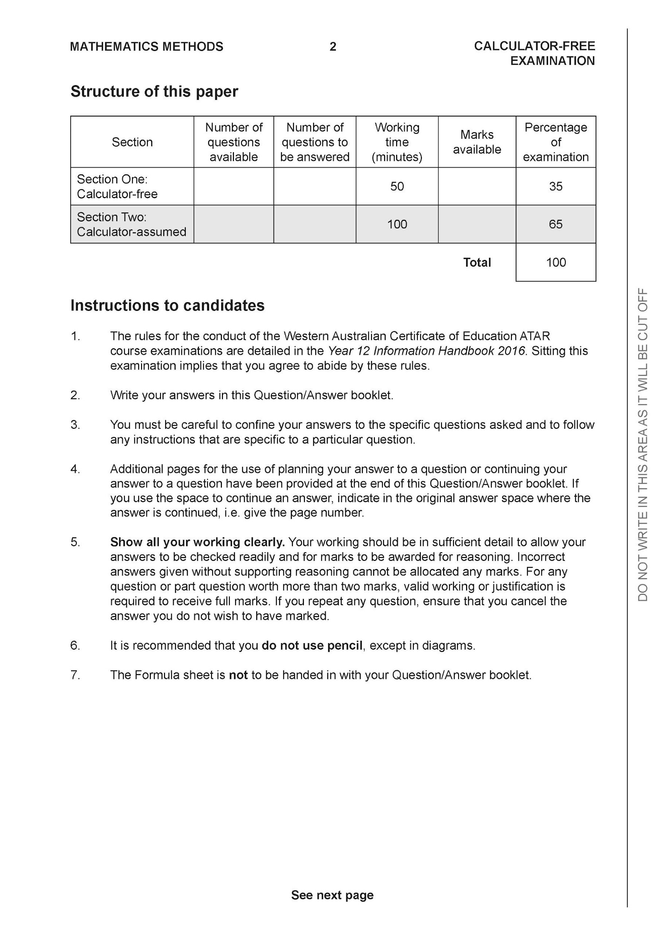

Section One: Calculator-free (52 Marks)

This section has nine (9) questions. Answer all questions. Write your answers in the spaces provided.

Spare pages are included at the end of this booklet. They can be used for planning your responses and/or as additional space if required to continue an answer.
● Planning: If you use the spare pages for planning, indicate this clearly at the top of the page.
● Continuing an answer: If you need to use the space to continue an answer, indicate in the original answer space where the answer is continued, i.e. give the page number. Fill in the number of the question that you are continuing to answer at the top of the page.

Working time: 50 minutes.

Question 1 (5 marks)

Solve the following

(a) $\frac{5x}{6}=\frac{7}{2}$ (1 mark)

(b) $\frac{3x}{5}-\frac{x}{4}=2$ (2 marks)

(c) $x^{3}+3x^{2}-4x=0$ (2 marks)

Question 2 (12 marks)

Brodie and his sister Ryanne are out playing fetch with their Dog, on a straight slope. The three are spread out evenly with the Dog being directly (half-way) in between the Brodie and Ryanne.

When modelled on a cartesian plane, the Dog’s position can be considered as (7.5, 2.5) and Ryanne’s position can be considered as (10, 3).

(a) Determine the coordinates of Brodie. (2 marks)

(b) Determine the equation of the slope. (3 marks)

(c) Brodie is flying a kite. If the line of the kite is running perpendicular to the slope, determine the equation that models the line. (3 marks)

(d) Ryanne throws the ball away from the Dog and the path of the ball can be modelled by the following quadratic equation.

$y= -\frac{x^{2}}{2}+x+1$

Determine the coordinates that the ball first lands on the slope. (4 marks)

Question 3 (3 marks)
Find in terms of $p$the remainder when $x^{3}-2x^{2}+px-6$ is divided by $x-2.$

Question 4 (3 marks)
Points M(p,6) and N(1,-2) are the end points of line segment MN. If the midpoint of line is (-3, q). Determine the value of p and q.

Question 5 (6 marks)

The function $y=f(x)$ is shown below.
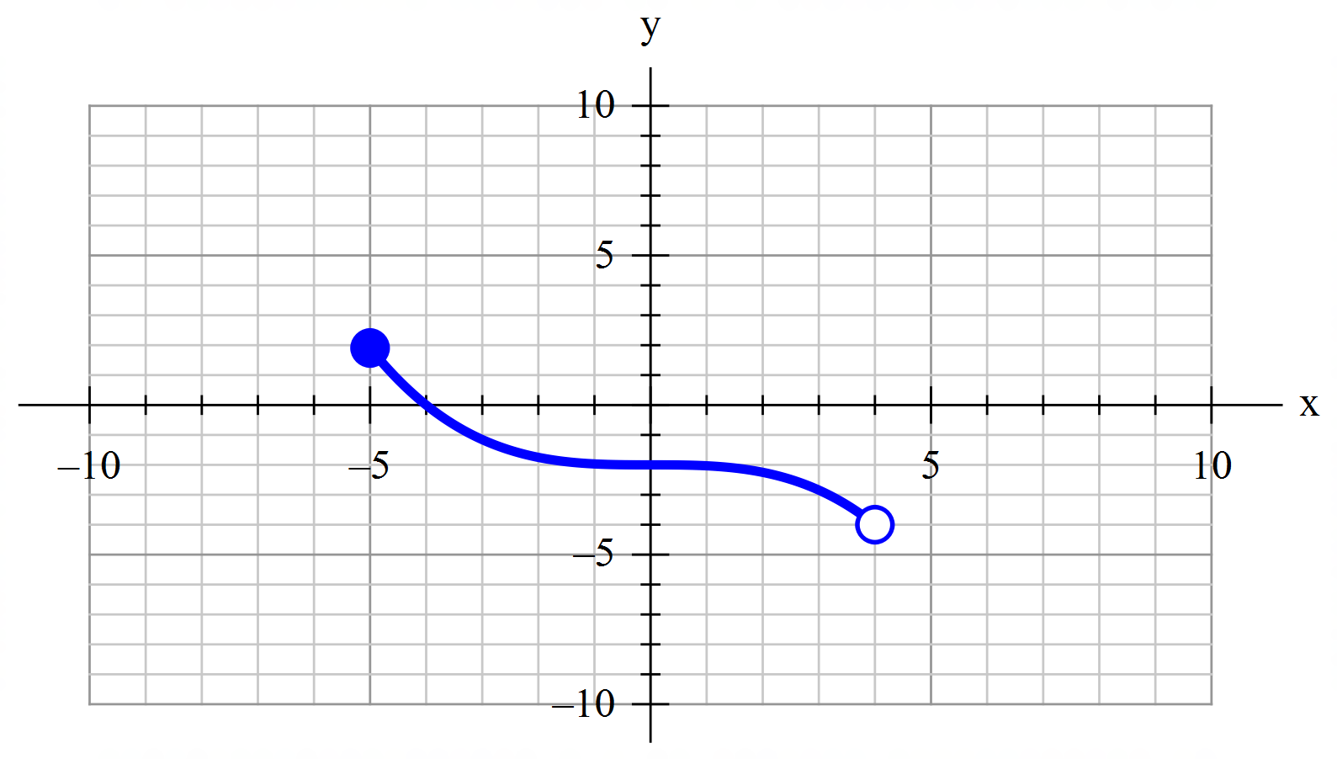

(a) State the range of $f(x)$. (1 mark)

(b) Another function is given by $g\left(x\right)=2f\left(x-3\right)$.

(i) Describe the transformation required to produce $g(x)$ from $f(x)$. (2 marks)

(ii) State the coordinate of the y-intercept under this transformation. (1 mark)

(c) On the same axes above, sketch the graph of $y=f\left(2x\right)+2$. (2 marks)

Question 6 (7 marks)
Given the equation $2^{x+1}+2^{3-x}=17, x ∈ R,$

(a) use a suitable substitution to rewrite the equation above as a quadratic equation,
(3 marks)

(b) hence, determine the solution(s) to the exponential equation. (4 marks)

Question 7 (6 marks)

Given $f\left(x\right)=ax\left(x^{2}+4x+3\right), -3<f\left(x\right)≤0$ and $f\left(1\right)=-24$

(a) Rewrite the function in factorised form, stating the value of $a.$ (3 marks)

t

(b) Sketch the function on the given domain. (3 marks)
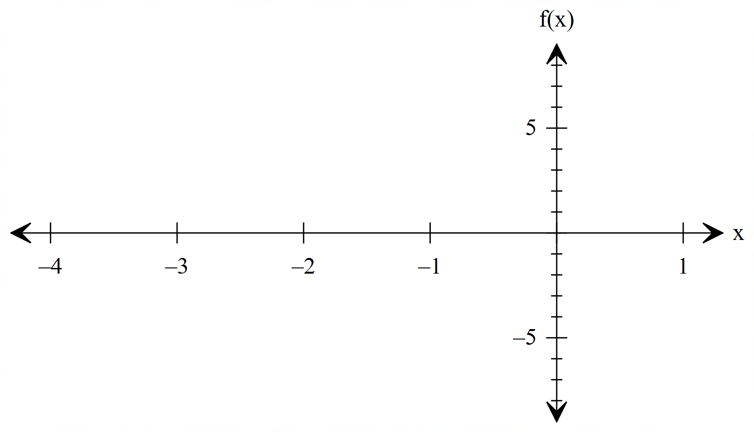

Question 8 (6 marks)

A relationship between $x$ and $y$ is given by $x=\frac{7}{2}y+2$.

(a) Determine $y$ when $x=23$. (2 marks)

(b) State, with justification, whether $x$ is a function of $y$. (2 marks)

(c) State, with justification, whether $x$ is proportional to $y$. (2 marks)

Question 9 (4 marks)

The quantity of light, $Q$, given out by a lamp is proportional to the square of the current, $I$, passing through the lamp. When $Q=1000$, $I=2$.

(a) Write an equation that relates $Q$ and $I$. (2 marks)

(b) Find the value of $Q$ when $I=3$. (1 mark)

(c) What happens to $Q$ when $I$ is doubled. (1 mark)

Additional working space
Question number:

Additional working space
Question number:

